EXPERIMENT – 7

Title
Smart City Traffic Management System – Congestion-Aware Traffic Signal Controller

Aim
To design and simulate a smart city traffic management system that dynamically controls traffic signals based on vehicle density, average speed, and vehicle waiting time using Python in Google Colab.

Apparatus / Software Required
- Google Colab
- Python 3
- Random library
- Matplotlib library
- IPython Display library

Objectives
To simulate traffic conditions on four road lanes (North, South, East, and West), calculate a congestion score using the number of vehicles, waiting time, and average speed, identify the most congested lane, dynamically provide a green signal to that lane, and visualize traffic parameters using graphs.

Theory
A Smart City Traffic Management System uses real-time traffic information to control traffic signals efficiently. In this experiment, four traffic lanes—North, South, East, and West—are considered.
The system monitors three important traffic parameters:
- Vehicle Density – Number of vehicles present in each lane.
- Average Speed – Average speed of vehicles in each lane in km/h.
- Waiting Time – Time for which vehicles have been waiting in the lane.
A congestion score is calculated using:
Congestion Score = (Vehicle Count × 2) + Waiting Time − Average Speed
A higher congestion score indicates greater traffic congestion. The lane with the highest score is selected for the green signal. A certain number of vehicles are then cleared from that lane, its waiting time is reduced, and its average speed is increased.
This provides a simple simulation of dynamic and congestion-aware traffic signal control for smart cities.

Algorithm
- Start the program.
- Import the required Python libraries.
- Define four traffic lanes: North, South, East, and West.
- Initialize the number of vehicles, average speed, and waiting time for each lane.
- Set the number of simulation cycles.
- Generate new vehicles arriving at each lane randomly.
- Update the vehicle count for all lanes.
- Randomly update the average speed of vehicles.
- Update the waiting time of vehicles.
- Calculate the congestion score for every lane using:
Score = (Vehicles × 2) + Waiting Time − Average Speed
11. Find the lane having the highest congestion score.
12. Select that lane for the green signal.
13. Clear a number of vehicles from the selected lane.
14. Reduce the waiting time of the selected lane.
15. Increase the average speed after traffic clearance.
16. Display the traffic parameters and congestion scores.
17. Plot vehicle density, average speed, and waiting time.
18. Repeat the process for all simulation cycles.
19. Display the simulation completion message.
20. Stop the program.

Procedure
- Open Google Colab and create a new notebook.
- Import the required Python libraries such as random, matplotlib, time, and IPython.display.
- Define the four traffic lanes as North, South, East, and West.
- Initialize the traffic parameters for each lane.
- Run the traffic simulation for the specified number of cycles.
- Generate random vehicle arrivals and update the traffic conditions.
- Calculate the congestion score for each lane.
- Identify the lane with the highest congestion score.
- Give the green signal to the selected lane.
- Clear vehicles and update the waiting time and speed.
- Display the current traffic parameters.
- Generate graphs for vehicle density, average speed, and waiting time.
- Continue the simulation until all cycles are completed.
- Observe the final simulation output.

Sample Initial Data
Lane | Vehicles | Average Speed (km/h) | Waiting Time (sec)
North | 12 | 28 | 25
South | 7 | 35 | 15
East | 15 | 22 | 40
West | 9 | 30 | 20

Sample Congestion Calculation
For the North lane:
Congestion Score = (Vehicles × 2) + Waiting Time − Average Speed
= (12 × 2) + 25 − 28
= 21
The same calculation is performed for South, East, and West lanes. The lane with the highest congestion score receives the green signal.

Expected Output
The program displays:
- Current traffic cycle
- Lane receiving the green signal
- Number of vehicles
- Average vehicle speed
- Waiting time
- Congestion score
- Number of vehicles cleared
It also displays three graphs:
- Vehicle Density – Shows the number of vehicles in each lane.
- Average Vehicle Speed – Shows the average speed for each lane.
- Vehicle Waiting Time – Shows the waiting time for each lane.

Output Observation
A typical output is:
=================================================================
SMART CITY TRAFFIC MANAGEMENT SYSTEM
=================================================================

Traffic Cycle : 4
Green Signal : North

Traffic Parameters
-----------------------------------------------------------------
North | Vehicles: 12 | Speed: 35 km/h | Waiting: 27 sec | Score: 43
South | Vehicles: 27 | Speed: 39 km/h | Waiting: 28 sec | Score: 43
East | Vehicles: 14 | Speed: 31 km/h | Waiting: 40 sec | Score: 37
West | Vehicles: 19 | Speed: 33 km/h | Waiting: 38 sec | Score: 43
-----------------------------------------------------------------

Action: 6 vehicles cleared from North lane.
The exact values may change each time because the program uses random traffic generation.

Phyton code:
# ============================================================
# Smart City Traffic Management System
# Congestion-Aware Traffic Signal Controller
# Google Colab Version
# ============================================================

import random
import matplotlib.pyplot as plt
from IPython.display import clear_output
import time

# ------------------------------------------------------------
# Lane Names
# ------------------------------------------------------------

lanes = ["North", "South", "East", "West"]

# ------------------------------------------------------------
# Initial Traffic Parameters
# ------------------------------------------------------------

vehicles = [12, 7, 15, 9]

average_speed = [28, 35, 22, 30] # km/h

waiting_time = [25, 15, 40, 20] # seconds

simulation_steps = 20

# ------------------------------------------------------------
# Traffic Simulation
# ------------------------------------------------------------

for step in range(1, simulation_steps + 1):

# New vehicles arrive
new_vehicles = [
random.randint(1, 6)
for _ in range(4)
]

vehicles = [
vehicles[i] + new_vehicles[i]
for i in range(4)
]

# Update average speed
average_speed = [
max(
10,
average_speed[i] + random.randint(-5, 5)
)
for i in range(4)
]

# Update waiting time
waiting_time = [
waiting_time[i] + random.randint(2, 8)
for i in range(4)
]

# --------------------------------------------------------
# Calculate Congestion Score
# --------------------------------------------------------

congestion_score = []

for i in range(4):

score = (
vehicles[i] * 2
+ waiting_time[i]
- average_speed[i]
)

congestion_score.append(score)

# Select most congested lane
active_lane = congestion_score.index(
max(congestion_score)
)

active_lane_name = lanes[active_lane]

# --------------------------------------------------------
# Green Signal Action
# --------------------------------------------------------

vehicles_cleared = min(
vehicles[active_lane],
random.randint(5, 10)
)

vehicles[active_lane] -= vehicles_cleared

# Reduce waiting time after green signal
waiting_time[active_lane] = max(
0,
waiting_time[active_lane] - 10
)

# Increase speed after traffic clearance
average_speed[active_lane] = min(
60,
average_speed[active_lane] + 5
)

# --------------------------------------------------------
# Clear Previous Output
# --------------------------------------------------------

clear_output(wait=True)

print("=" * 65)
print(" SMART CITY TRAFFIC MANAGEMENT SYSTEM")
print("=" * 65)

print(f"\nTraffic Cycle : {step}")
print(f"Green Signal : {active_lane_name}")

print("\nTraffic Parameters")
print("-" * 65)

for i in range(4):

print(
f"{lanes[i]:8} | "
f"Vehicles: {vehicles[i]:2} | "
f"Speed: {average_speed[i]:2} km/h | "
f"Waiting: {waiting_time[i]:2} sec | "
f"Score: {congestion_score[i]:3}"
)

print("-" * 65)

# --------------------------------------------------------
# Graph 1 - Vehicle Density
# --------------------------------------------------------

plt.figure(figsize=(8, 5))

plt.bar(
lanes,
vehicles
)

plt.xlabel("Traffic Lanes")
plt.ylabel("Number of Vehicles")
plt.title(
f"Vehicle Density - Cycle {step}"
)

for i, value in enumerate(vehicles):

plt.text(
i,
value + 0.5,
str(value),
ha="center"
)

plt.show()

# --------------------------------------------------------
# Graph 2 - Average Speed
# --------------------------------------------------------

plt.figure(figsize=(8, 5))

plt.plot(
lanes,
average_speed,
marker="o"
)

plt.xlabel("Traffic Lanes")
plt.ylabel("Average Speed (km/h)")
plt.title(
"Average Vehicle Speed"
)

plt.grid(True)

plt.show()

# --------------------------------------------------------
# Graph 3 - Waiting Time
# --------------------------------------------------------

plt.figure(figsize=(8, 5))

plt.bar(
lanes,
waiting_time
)

plt.xlabel("Traffic Lanes")
plt.ylabel("Waiting Time (seconds)")
plt.title(
"Vehicle Waiting Time"
)

plt.show()

print(
f"\nAction: {vehicles_cleared} vehicles cleared "
f"from {active_lane_name} lane."
)

# --------------------------------------------------------
# Next Cycle
# --------------------------------------------------------

time.sleep(1.5)

# ------------------------------------------------------------
# Final Message
# ------------------------------------------------------------

print("\n" + "=" * 65)
print(" TRAFFIC SIMULATION COMPLETED")
print("=" * 65)

print("Dynamic congestion-based traffic control completed successfully.")

Output:
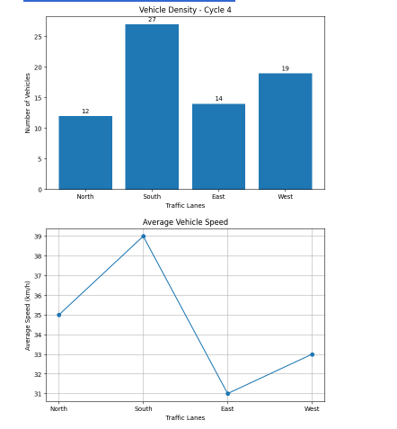
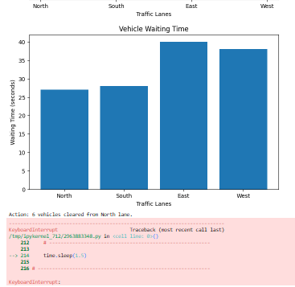

Result
The Smart City Traffic Management System was successfully simulated using Python in Google Colab. The system dynamically identified the congested lane using vehicle density, average speed, and waiting time, and provided the green signal to the selected lane. The traffic parameters were successfully visualized using graphs.

